Study Design

The last chapter introduced the theoretical background of this work. Central points are the psychology foundation of emotions, motivation and personality. It also covers the most important aspects of game design and race games. In this chapter we build on the theoretical foundation to investigate driving behaviour. We developed a race game with integrated survey. The game allows analysing driving behaviour in video games, improving the learning process and identifying risk factors. We build our own game to have total control over the data recorded tailored to our requirements.

A total of 48 people participated in this study. Participants came from different backgrounds and between the ages of 20 and 50 years. In order to participate they only needed a computer or laptop.

The study consists of three major parts:

* Personality test
* Driver skills evaluation
* Motivation assessment

The first step is to measure the personality traits of participates. Section 1 explains the two instruments we used: Big Five and Sensation Seeking. The Big Five is a reliable way to measure the five domains of personality: Extraversion, Neuroticism, Conscientiousness, Agreeableness, and Openness. Sensation seeking indicates a willingness to take risks. We expect to find relationships between personality trades and unsafe driving practices based on previous research(see).

In section 2 we introduce the racing part of our video game. It’s a first-person simulation style racing game. Participants have to drive several rounds. We aimed for a medium grade of driving skill, focusing on realistic physics. Drivers have to master proper cornering technique and precision racing manoeuvres in order to manufacture a fast and clean lap. We record the position, velocity while driving to compare drivers, detect driving errors and find correlations.

The third part of the study focuses on measuring the emotion between runs is explained in section 3. The emotions can only be assessed with self-report measures. The instrument we use is the” Geneva Emotion Wheel”. It’s a very successful visual tool. We integrated the tool after each lap. Emotions and motivation influence our driving and learning behaviour.

# Personality Types

This framework includes two personality surveys. In this section we want to discuss how we measure personality. We also elaborate how the tools are integrated in the survey. In subsection 1 we discuss the Big Five personality traits. The Big Five personality traits have been found to influence the learning behaviour and performance. The second personality measurement tool we integrated is the Sensation Seeking Scale. The Sensation Seeking Scale is examined in subsection 2. The sensation seeking trait indicates a willingness to take risks. In total we extract six personality variables—neuroticism, extraversion, openness, agreeableness, conscientiousness and sensation seeking.

# Big Five Personality

We already discussed the theoretical background and related research of the Big Five personality traits in section \ref{sec:rel:bigfivepersonality}. The Big Five theory presents a model in which personality is organized into five factors. Table 1 shows the five factors and their personality characteristics.

Table 1: Five Factors and personality characteristics

|  |  |
| --- | --- |
| Big Five personality | High score vs Low score |
| extraversion | outgoing/energetic vs. solitary/reserved |
| agreeableness | friendly/compassionate vs. challenging/detached |
| conscientiousness | efficient/organized vs. easy-going/careless |
| neuroticism | sensitive/nervous vs. secure/confident |
| openness | inventive/curious vs. consistent/cautious |

There are a multitude of instruments to estimate the Big Five personality. Big Five instruments are generally lengthy, most take a five minutes or more. \textcite{Rammstedt2007} developed a shorter version the 10 item Big Five Inventory (BFI-10). BFI-10 assesses the five dimensions with a 10 questions in only 1 minute. This makes it perfect for our application. It can be done quick and easy at the beginning of our game. The participants have to rate how well the BFI-10 statements describe their personality. The rating scale consists of four-steps from 1 “disagree strongly” to 4 “agree strongly”. The statements are listed in table 2.

Table 2: Big Five Inventory-10 (BFI-10)

|  |  |
| --- | --- |
| I see myself as someone who… |  |
| … is reserved  … is generally trusting  … tends to be lazy  … is relaxed, handles stress well  … has few artistic interests  … is outgoing, sociable  … tends to find fault with others  … does a thorough job  … gets nervous easily  … has an active imagination |  |

The items were selected using psychology experts judgment and empirical item analyses. The BFI-10 consists of the most prototypical traits that define each Big Five domain. Given the short length the BFI-10 possesses acceptable psychometric properties.

In virtual driving we integrated the questions directly into the game. Figure 1 shows one in-game question. Only one question is shown at any time. After the participant locks in the next question is shown. The questions are randomized.

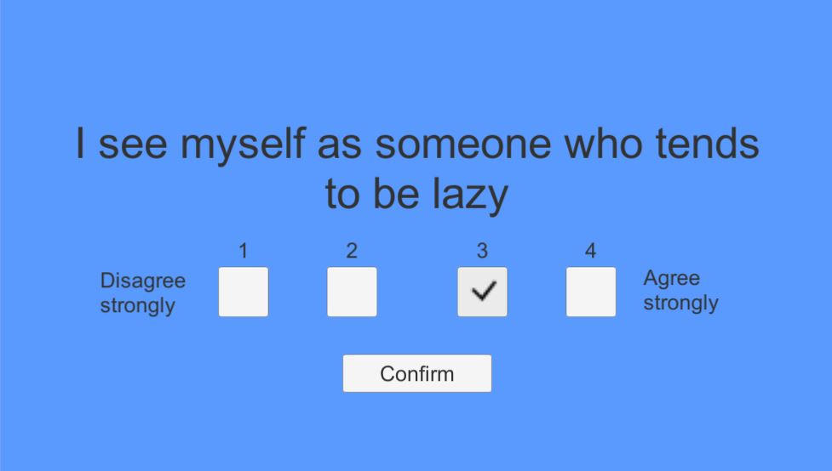

Figure 1: BFI-10 statement in virtual driving

After the participant has gone through all items, the personality score is calculated. Every Big Five personality dimension is represented with 2 items in BFI-10.

Scoring the BFI-10 scales: Extraversion: 1R, 6; Agreeableness: 2, 7R; Conscientiousness: 3R, 8; Neuroticism: 4R, 9; Openness: 5R; 10 (R = item is reversed-scored).

Expected result:

Measuring personality in one minute or less: A 10-item short version of the Big Five Inventory in English and German - Rammstedt

# Driving Skills

We measured vehicle speed and position in the lane.

It records the spatiotemporal data of the race cars in every step (e.g. position, velocity, time).

# GEW

The assessment of emotional reactions is therefore important to understand how to improve driving.